6COSC006W – Final Year Project

Interim Project Report (PID)

Contactless Voucher

Shouyi Cui (w1618594)

**Supervisor:** Barbara Villarini

BSc (Hons) in Software Engineering

School of Computing & Engineering

University of Westminster

Date 30th November 2019

**Contents**

**Section Page**

1. INTRODUCTION 3
2. BACKGROUND 5
3. REQUIREMENTS 7
4. METHODOLOGIES 9
5. DESIGN 9
6. MILESTONE AND TIMELINE 10
7. REFERENCES & BIBLIOGRAPHY 10

**List of figures**

Figure 1: Example of a digital gift card using the barcode technology

Figure 2: Number of NFC enabled mobile devices worldwide

Figure 3: Stakeholders onion diagram

**Glossary**

NFC stands for Near-field communication is a set of communication protocols that enable two electronic devices, one of which is usually a portable device such as a smartphone, to establish communication by bringing them within 4 cm of each other. (NFC Wikipedia, n.d.)

POS stands for Point Of Sale which is a critical piece of a point of purchase, refers to the place where a customer executes the payment for goods or services and where sales taxes may become payable. It can be in a physical store, where POS terminals and systems are used to process card payments or a virtual sales point such as a computer or mobile electronic device. (Investopedia, n.d.)

User journey represents a sequence of events or experiences a user might encounter while using a product or service. A user journey can be mapped or designed to show the steps and choices presented as interactions, and the resulting actions. (Every Interaction, n.d.)

**1. Introduction**

Nowadays there are many possible ways to make a digital payment securely and safely. In the developed countries, it is very common to see people walking around supermarkets without even a wallet and paying with the mobile phone using Apple Pay, Google Pay or similar technologies that involves some connection with a bank card details (such as Samsung Pay, WeChat wallet, AliPay and so on).

**1.1 Problem statement**

The idea is to increase the capability of this technology in order to allow the user to redeem a voucher or coupon so that the process can be made through the NFC ability of the phone. The current most popular promotional campaigns require customers to follow a certain user journey where they can make mistakes and then they never reach the intended result.

For example, Voucher Express allows customer to generate voucher that they can use either on the online shop or in the local store.

[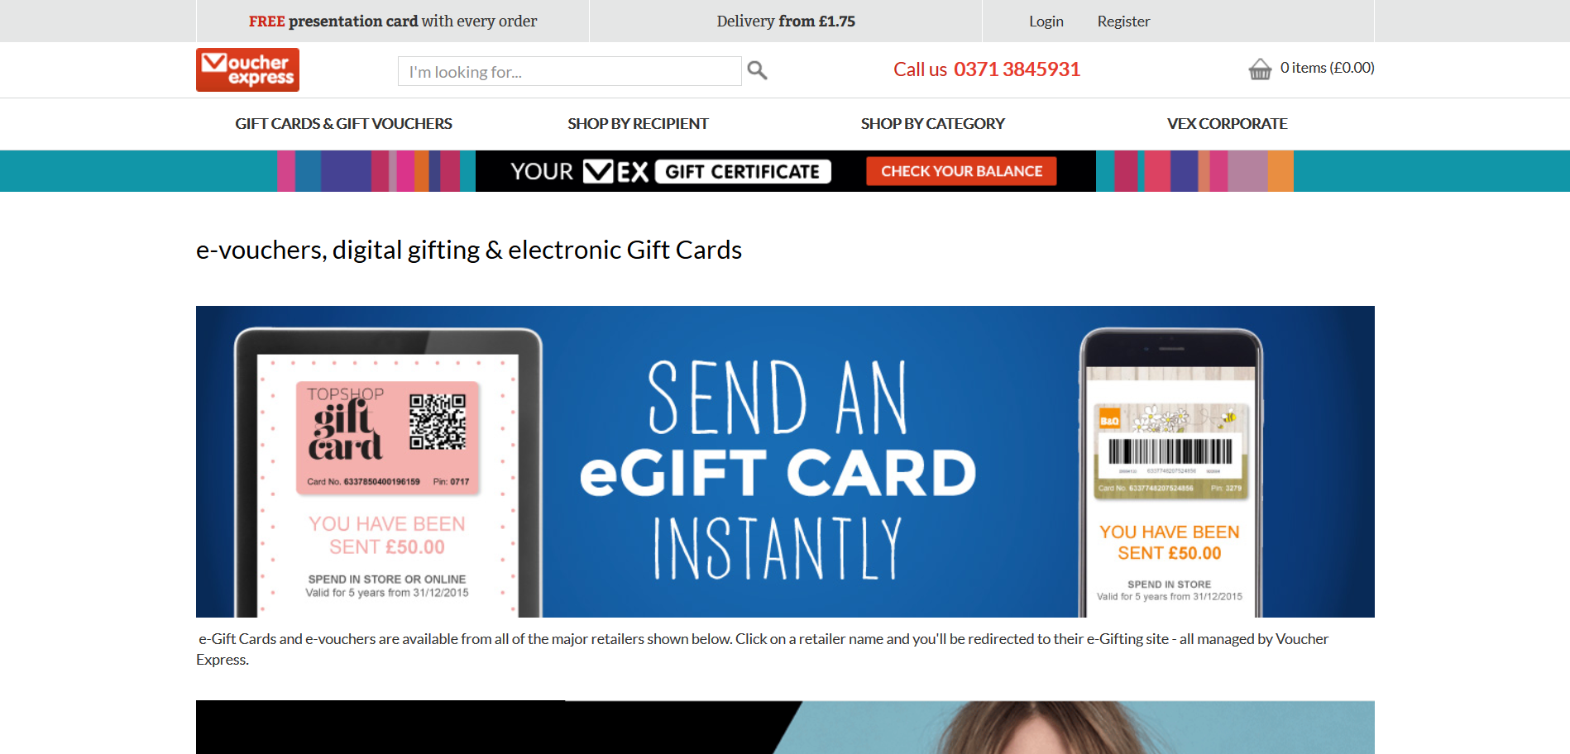](https://www.voucherexpress.co.uk/content/e-vouchers-from-voucher-express.aspx)

Figure 1. Example of a digital gift card using the barcode technology (Screenshot taken on November 2019)

In the local store, the customer would need to show a barcode that should be scanned at the till. Sometimes it can happen that the scansion fails and therefore the cashier needs to manually enter the numbers and/or letters of the voucher. Although the technology involved is very similar to a contactless payment, there is no such feature that allows the customer with the option of using the voucher through the NFC technologies. My solution will provide an easier alternative for the customer who will just need to “tap” his phone like he was doing a contactless payment.

Therefore, the result would be a simplification of the user completing a market campaign, which means the possibility to make this feature suit not only for promotional temporary products but also for long term loyalty schemes that features the release of digital vouchers.

Moreover, in terms of ethic and ecologic point of view, this project has the potential to save the waste of plastic and paper by avoiding the demand of printed barcodes and plastic cards that “[…] have actually been the most requested gift in America” (Long, 2015).

[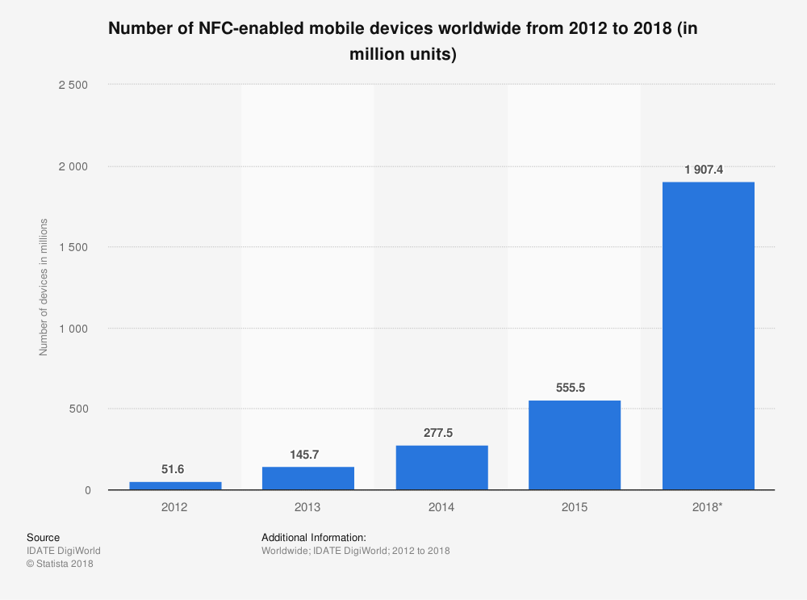](https://www-statista-com.ezproxy.westminster.ac.uk/statistics/461494/nfc-enabled-mobile-devices-worldwide/) Figure 2 Number of NFC-enabled mobile devices worldwide from 2012 to 2018 (From Statista on November 2019)

“Around two million cards are produced each year – using about 2,500 tonnes of plastic.” (Perchard, 2017) and by covering that service using the NFC feature which is accessible to more than 1 billion devices worldwide (as shown in fig.2) I believe that there will be less card production.

Lastly, in terms of research, it would allow me to understand and learn more about what are the limits of the technology and what are the possible useful other options other than payment.

**1.2 Aim and objectives**

The main purpose of this software is to enable a new form of transaction using the NFC technology that does not necessarily need to be linked to a bank account and can be used as a voucher. It will be a software whereby the customers can redeem a voucher as easy as making a contactless payment.

To achieve the desired goal, I will need to complete this list of objectives:

* Gain in-depth understanding on NFC capabilities
* Research NFC security known issues and always be aware on related news
* Make sure the software works in the most similar way on iOS and Android
* Develop a prototype to use as demo for stakeholders
* Constantly receive feedback from different sources to gain a wider perspective of the project
* Unit test and penetration test to assure step by step that all requirements are meet and reliable
* Source control to make sure there is trace of the work done in case of work lost or not working as expected
* Time tracking and documentation of the work done for the project
* Make sure deployed project is working properly, tested and on time.

Moreover, I would like to achieve some additional features (in descending order of importance):

1. Collection of loyalty points through contactless payment automatically
2. Make the digital voucher transferrable among same e-wallets
3. Develop the software in a web-app so that the user does not need to install any application on the phone

**2. Background**

In terms of contactless technology for transaction there are already services like Google Pay for Android devices and Apple Pay for iOS devices. Both are defined digital wallets where the user can register many different cards such as loyalty cards. The main use of these two applications is to enable the contactless payment linked with a Debit or Credit card issued by banks and therefore the use of POS. Once the users have been registered, they will also be able to make payments through the same account for online payments through shopping online.

**2.1 Literature survey**

The feature I am going to develop focuses on the type of loyalty cards whereby the user can make a transaction that needs to be validated but it does not require any involvement with a bank institution directly. There are already many types of services that provides digital vouchers. From the grocery shop loyalty scheme such as Tesco (Tesco ClubCard), Sainsbury (Nectar), CO-OP (Co-Op Member), Waitrose (MyWaitrose) to even the coffee shops loyalty scheme such as Caffè Nero (Caffè Nero Loyalty Card) and (Costa Coffee Club). The list goes on and on for each company that sells always the same product and therefore needs the customer to come very often. The functionality in those vouchers rely on a QR-Code (WRITE EXPLICITLY THAT NFC DOES NOT NEED TO OPEN THE APP DIRECTLY), barcode or a set of character and/or digits but the final result will be the same as my project. Therefore, all the aforementioned services can be a useful guidance.

In order to get more useful information on the technology, the documentation provided both by Android (Android, 2019) and Apple (Developer, 2019) Developers are going to be essential for the understanding.

As the Android platform describes it, there are a different range of complexity when talking about Tags. From the simplest read and write tag to the most complex containing operating environments that allows complex interactions with code executing on the tag (Developer, s.d.)

According the same source, there are three main modes of operation:

1. Reader/writer mode, allowing the NFC device to read and/or write passive NFC tags and stickers.
2. P2P mode, allowing the NFC device to exchange data with other NFC peers; this operation mode is used by Android Beam.
3. Card emulation mode, allowing the NFC device itself to act as an NFC card. The emulated NFC card can then be accessed by an external NFC reader, such as an NFC point-of-sale terminal.

For the purpose of this project the third case will be the most useful scenario. The application will theoretically act as a card and then the use will be able to use it as a payment method.

**2.2 Review of projects/applications**

At the moment, I cannot find anything that provides the same service as the contactless transaction I intend to develop. The most similar remains the contactless payment from a functionality point of view, and loyalty scheme as end result.

Throughout my research and conversation with the stakeholders I have found some companies that provide similar technologies:

|  |  |  |
| --- | --- | --- |
|  | Pros | Cons |
| Google Pay / Apple Pay as mentioned before is the most similar example to what I want to develop. | 1. Fast service 2. Secure and reliable 3. Scansion the card and fill the details automatically 4. Supported by a wide variety of mobile phone 5. Does not need internet connection from who makes the payment | 1. Restricted by the type of card issued by the bank |
| (Embargo, 2019) is a mobile application where there are rewards scheme for people who goes to social place such as pubs and restaurants. They work with many food markets as well and they just require the user to register into their service. | 1. No need of user personal details 2. It works similar to the NFC, but it uses Bluetooth, GPS and Wi-Fi 3. Fast user journey | 1. The user must have Bluetooth, GPS and Wi-Fi enabled in order to work 2. Relies on a good connection environment |
| (jisp, 2019) is a mobile application where you need to register with some payment system in order to buy products in certain shops.  Talking with the company CEO it has been discovered that they have done many campaigns and that they trying to develop a new system where people can order food by tapping on what they want. | 1. Completely NFC 2. User can do find everything they need within the mobile application 3. Can monitor user history to customise what they may want | 1. Requires an account where there is a debit card linked 2. It is necessary to have a customised shop with their service and technology, therefore it is not available in many places |

**2.3 Review of tools and techniques**

Tools that I could use, not those I am using. Including advantages and disadvantages.

The following list represents what are the most useful and helpful skills and tools to carry on working for this project.

Technical Skills:

* Programming languages to develop mobile application on Android and/or iOs such as JavaScript, XML and Swift
* Knowledge of SQL queries and Database Systems in order to store voucher data
* Knowledge of agile methodology to make sure everything is scalable
* Familiarity with GitHub branches, commit descriptions and therefore version control
* Familiarity within Azure Portal and Azure DevOps as possible development environment. This depends on the time left and possible extra implementation

Non-Technical Skills:

* Genuine curiosity and interest in the NFC to make sure to be up to date with the latest news
* Professional attitude to maintain good communication among the different stakeholders
* Active listening of the environment and good on eye to spot possible features in real life situations
* Good decision making and pragmatic to make the software efficient

1. **Requirements**
   1. **Stakeholders**

The stakeholders that have been identified are:

Retailers, mobile users with their device and technical team for the maintenance of the system. All of the aforementioned individuals are part of the inner circle of a hypothetical onion diagram (fig.3) can be referred to as *the system*. These are the essential part of the product and service.

Brands, owner and shop customers will be part of the *containing system.* These stakeholders may not interact with the product directly but they get advantage from it.

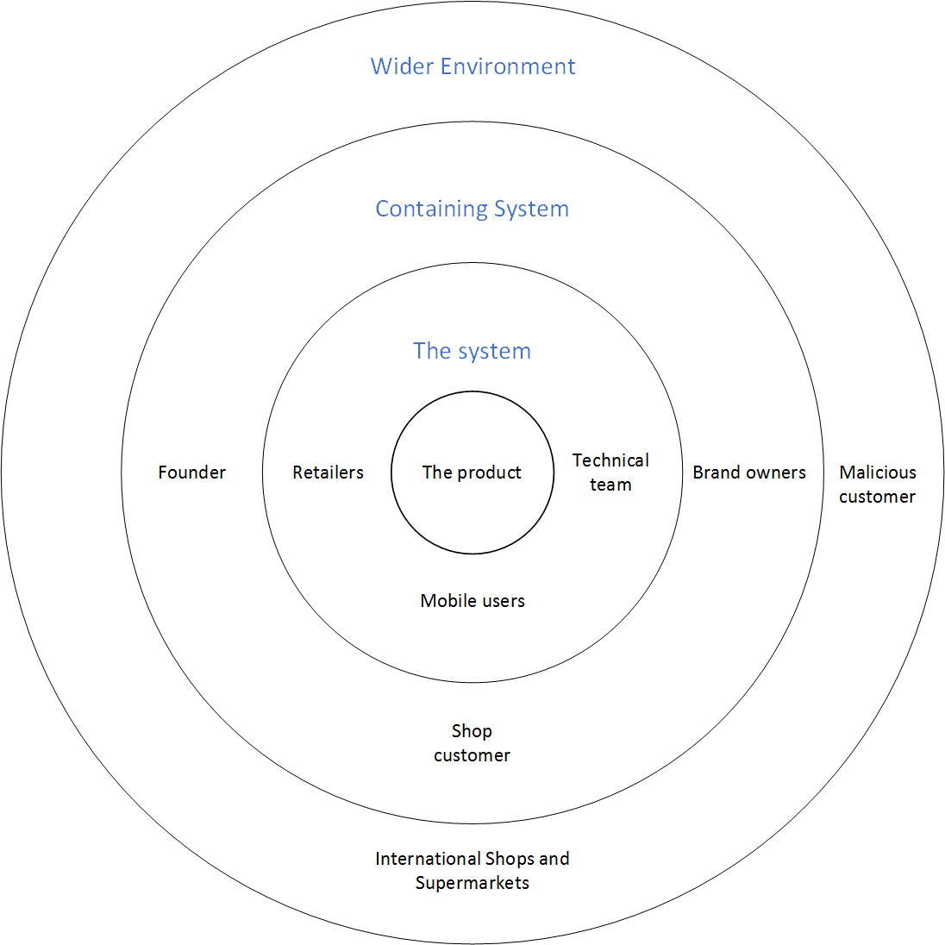In the *wider environment* there will be international and national supermarkets with brands that may use the same service in different scenarios and increase the demand of new solutions. There is also a consideration for possible hackers or malicious customers that intend to steal and illegally take advantage from others through this service.

Figure 3 Stakeholders onion diagram

* 1. **Gathering requirements**

In order to achieve the success of this project, a lot of research and meetings **(Research on what, meeting with whom?)** have been setup. The result of this process has been very useful to find out new requirements.

It is clear that a very important part of the application will be the speed of confirmation and trustworthiness in terms of transaction security.

The results have shown the importance for people using this technology that the process needs to be for small transaction as the limit £30 for payments in the shops. Therefore, the target and most useful case of this service would be people in a hurry like in train stations or buying food on the way to work.

* 1. **Modelling requirements and**

**relevant diagrams**

USE CASE – TABLE WITH THE CONDITIONS

* 1. **List of project requirements**

**Classify by priority**

List of non-functional requirements:

* Must be a mobile application available on Android
* Must be a mobile application available on iOS
* Must be supported for more than 80% of the mobile phones on the market
* User must agree on data consent, NFC access and other essential systems for the application to work properly
* User must know the transaction result by sound and/or vibration feedback

List of functional requirements:

* User must be able to create an account registered with the service
* User should be able to add a digital voucher by redirect of a webpage
* User must be able to add a voucher manually in case the automatic redirect does not work
* User must be able to redeem the voucher by NFC technology when the phone is unlocked
* User must not be able to redeem the voucher when there is possible security breach
* User must be able to choose manually what voucher to use
* User must be able to receive help by F.A.Q.
* Must have notification system to update possible vouchers to use

Due to the complexity of the project and the fact that the requirements may change while working I have decided to follow agile methodology. Using this technique, I will be able to keep track of the work done and give priority to relevant tasks when needed.

Moreover, based upon researches and personal experience gained I have set another list of requirements that may be useful:

* GPS can be asked in order to give a more precise feedback in case and at the same time is possible to let the user know that when they go to Tesco and pay without scanning their card
* Gamification of the mobile application that engages the user to know better the brands that are doing the promotion.
  1. **Legal, social and ethical issues**

An important aspect is the network of devices to use this application. It will be outstanding to make it available in every POS like any new bank card. Although this implies some legal issues related to the finance market and what the banks response would be.

It will be very important to satisfy the security issues because this technology is very vulnerable to hackers (Doffman, 2019). Moreover, I will need to ensure a fast service so that the customer can see the time gained by this technology.

1. **Methodologies**

The current process of the delivery of the product is waterfall methodology since the next steps are always restricted by the previous. Without any idea and the potential features of the NFC there is not much improvements that can be done yet. [To be continued.]

1. **Design**

The design of the application is going to be minimalistic because it will not need the user to make many actions. If the goal is set to create this application cross-platform between iOs and Android that is going to change the design of the software. Because of this, the design part of the application is still not ready to be discussed as the study and research process has not been completed yet.

**5.1 Tools for implementation**

The following list represent the tools that are being used or will be used for the purpose of this project:

* GitHub for version control of the code as well as documentation but Dropbox will be used more often for documentation on the cloud system as it allows automatic synchronisation across different devices
* Paymo as project management tracker
* Possible use of Microsoft Azure Cloud in order to develop the software as Web Application
* IDE such as Visual Studio 2019, Android Studio, Xcode and Atom
* Mozilla Thunderbird and Gmail as email system to contact supervisor and third parties people involved in the feedback of the project.
* Mozilla Firefox Developer, Google Chrome as browser for research and different testing environment
* Microsoft Office Word, OneNote, Excel and Adobe Acrobat Reader for documentation and data analysis.
* Postman for API testing and testing
* WinMerge to find document or code differences
* Android and/or iOS mobile phones to carry on testing (in my case it would be a Samsung Galaxy Note 9)

**6. Milestones and timeline**

Some test and learning has been achieved. Although is not enough to estimate a delivery time on when the application can be possibly finished.

The remaining task are many and first of all is to complete a demo application by the end of February.

Hopefully, the application will be ready to be further improved in March before the final submission in April.

**7. References & bibliography**

Android, 2019. *NFC documentation.* [Online]   
Available at: https://developer.android.com/guide/topics/connectivity/nfc/nfc  
[Accessed November 2019].

Caffè Nero Loyalty Card, n.d. [Online]   
Available at: https://caffenero-yoyowallet.zendesk.com/hc/en-us/articles/360023132413-FAQs-Caff%C3%A8-Nero-Loyalty-Card  
[Accessed October 2019].

Co-Op Member, n.d. [Online]   
Available at: https://www.coop.co.uk/membership  
[Accessed November 2019].

Costa Coffee Club, n.d. [Online]   
Available at: https://www.costa.co.uk/coffee-club/  
[Accessed October 2019].

Developer, A., 2019. *Core NFC.* [Online]   
Available at: https://developer.apple.com/documentation/corenfc  
[Accessed November 2019].

Doffman, Z., 2019. *https://www.forbes.com.* [Online]   
Available at: https://www.forbes.com/sites/zakdoffman/2019/11/02/new-android-threat-contactless-payment-technology-open-to-attackchange-your-settings/#47831ff25cde  
[Accessed November 2019].

Embargo, 2019. [Online]   
Available at: https://www.embargoapp.com/

Every Interaction, n.d. [Online]   
Available at: https://www.everyinteraction.com/definition/user-journey/  
[Accessed November 2019].

Investopedia, n.d. [Online]   
Available at: https://www.investopedia.com/terms/p/point-of-sale.asp  
[Accessed November 2019].

jisp, 2019. [Online]   
Available at: https://www.jisp.com/

Library, B., 2019. [Online]   
Available at: http://explore.bl.uk/primo_library/libweb/action/search.do?vid=BLVU1

Long, H., 2015. *https://edition.cnn.com/business.* [Online]   
Available at: https://money.cnn.com/2015/08/10/investing/gift-cards-soar-in-popularity/  
[Accessed November 2019].

MyWaitrose, n.d. [Online]   
Available at: https://www.waitrose.com/home/mywaitrose/mywaitrose_welcome.html  
[Accessed November 2019].

Nectar, n.d. [Online]   
Available at: https://www.sainsburys.co.uk/webapp/wcs/stores/servlet/gb/groceries/new---trending/nectar--?  
[Accessed November 2019].

NFC Wikipedia, n.d. [Online]   
Available at: https://en.wikipedia.org/wiki/Near-field_communication  
[Accessed November 2019].

Perchard, E., 2017. *https://resource.co/.* [Online]   
Available at: https://resource.co/article/could-green-solution-plastic-gift-vouchers-be-cards-11964  
[Accessed November 2019].

Tesco ClubCard, n.d. [Online]   
Available at: https://secure.tesco.com/clubcard/  
[Accessed November 2019].